CheckIn'Out App ( Attendance App ) User Manual ADMIN PANEL
1. Login :
- You need to login to the admin panel of the attendance app to view its features. The username and password will be setup by the company.
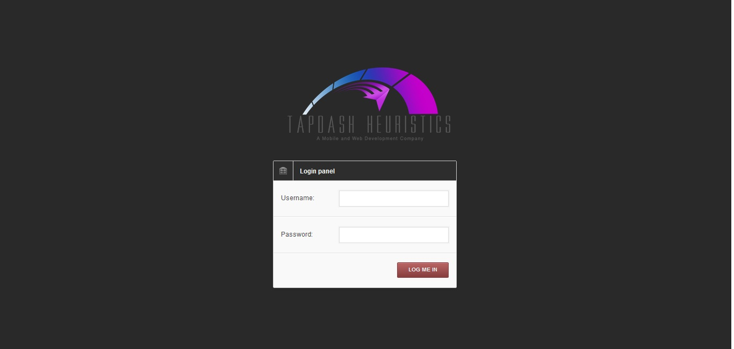

2. Attendance Logs:
- After Loggin in, the landing page will be the attendance log, you can set up the date range and view the employees' attendance and time logs.
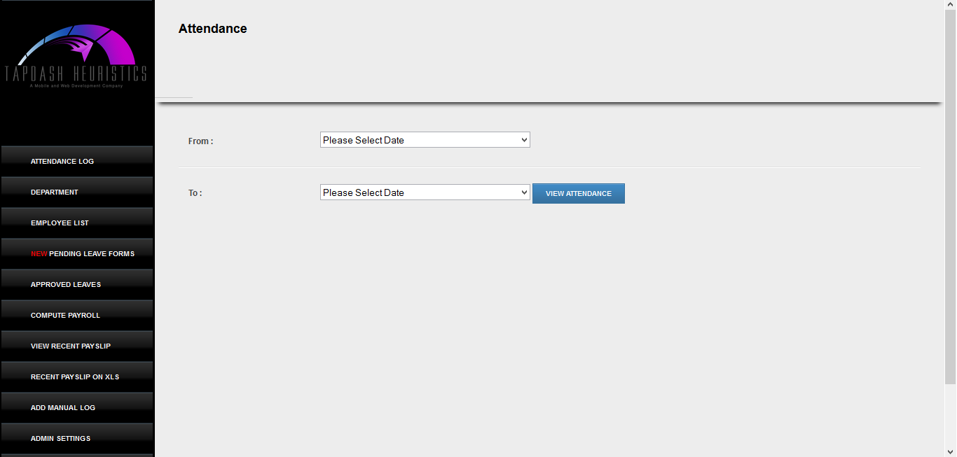

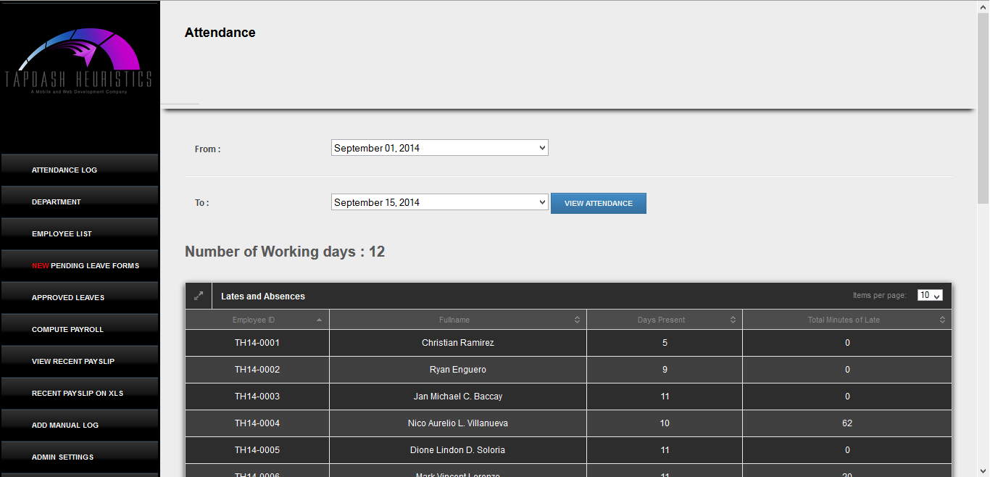

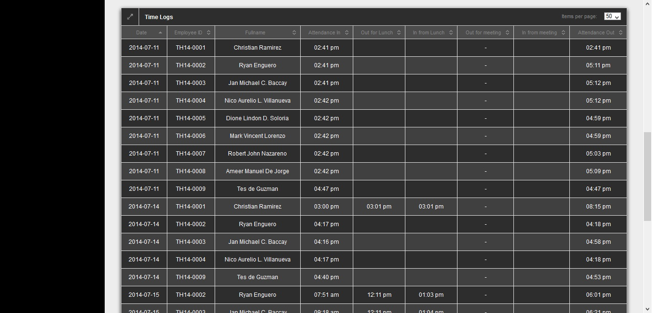

3. Employees List :
This page will let you view the complete list of employee and their corresponding qr codes.
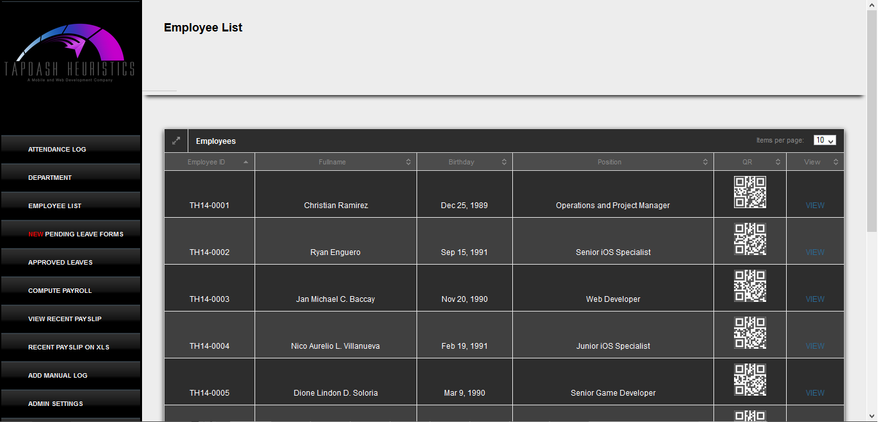

4. Pending Leave Forms:
This page will let you see the leave forms that the employees filed via mobile app. You can view them and approved if its reasonable.
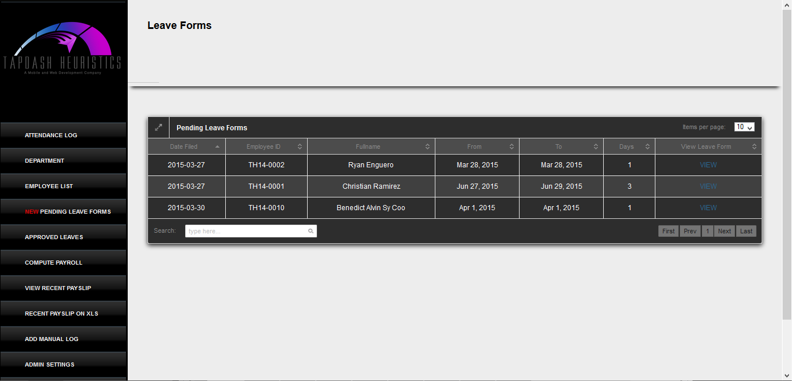

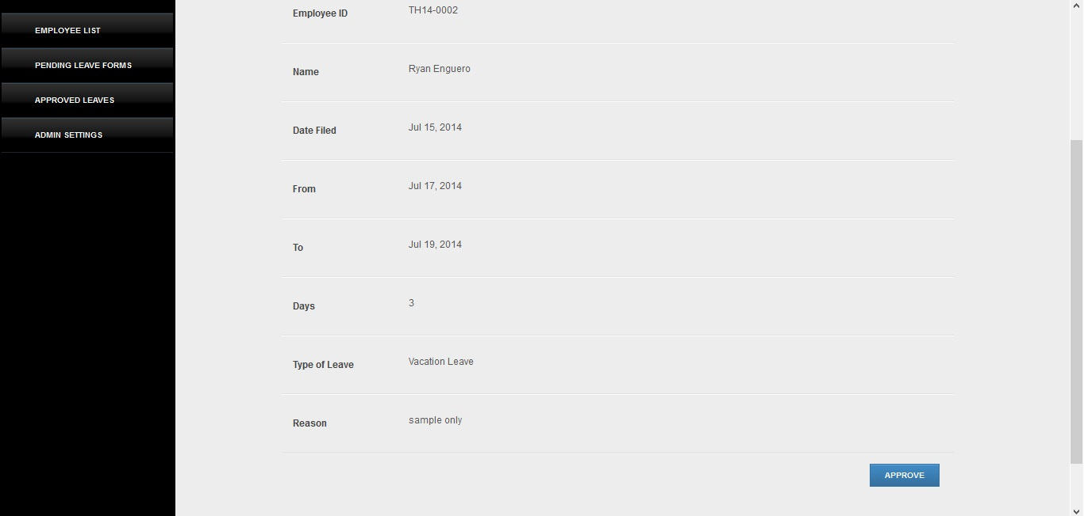

5. Approved Leave forms:
After you approved a leave form, you can see it on this page, this will record all the employees' leaves and monitor them accordingly.
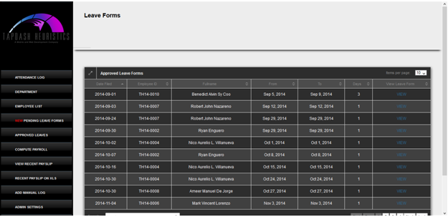

6. Computation of Payroll:
Payroll can be auto computed, just enter the range date of the cutoff

7. Viewing of the recent payslip:
In the "View recent payslip" tab, you can view all the employees payslip and download it for printing.

8. Payslip on XLS:
Payroll can also viewable on excel file format

9. Add Manual Log:
If some of the employees forgot to time in on a certain day, Admin can manually log them on the system.

FOR CLIENTS WHO HAS EXISTING BIOMETRICS:
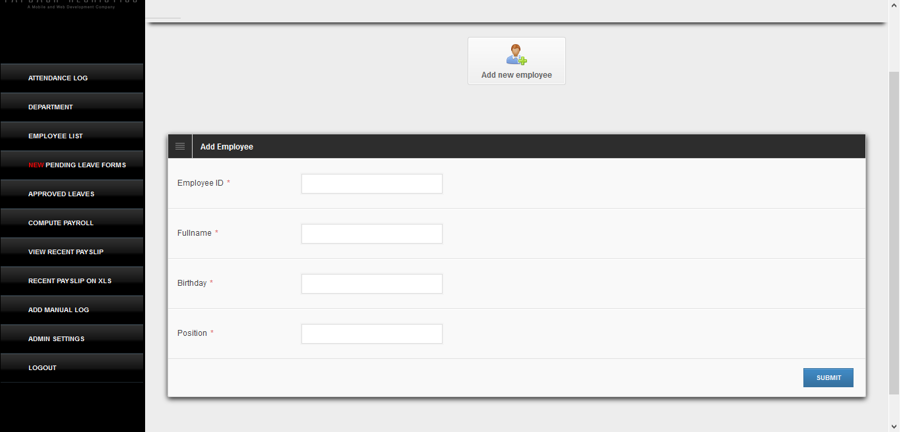
You can ADD employees through the admin panel without registering on the iPad.

You can upload the Attendance Log of the existing biometrics on the system via xls file
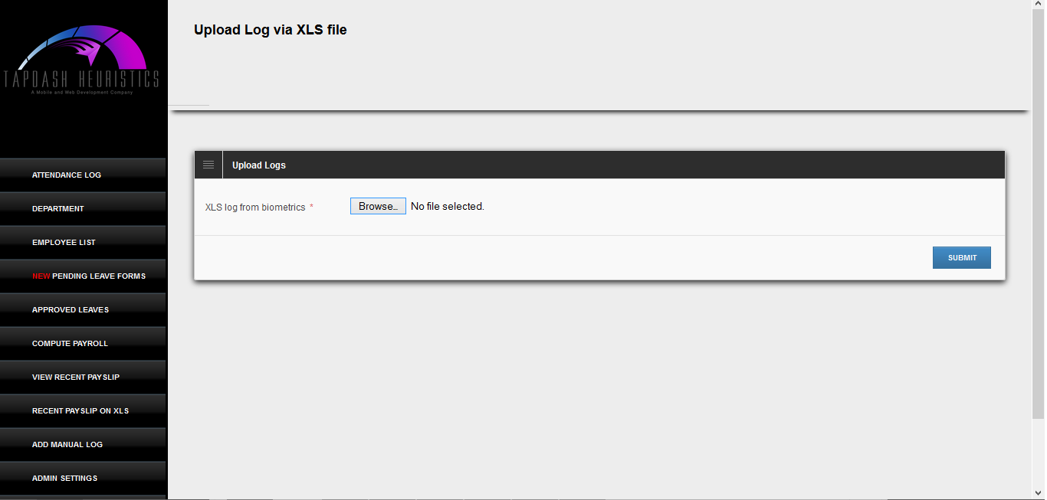

After Uploading your Logs, you can now view and compute the payroll

